Q)1. To Install Linux VM, Configure GCC, Setup Git Repository, Create Project Structure, Understand Shell Architecture, Build Initial Makefile

To Analyze process abstraction, execute fork(), understand exec() family, analyze parent-child relationships, inspect process tree, practice system call tracing

Code: 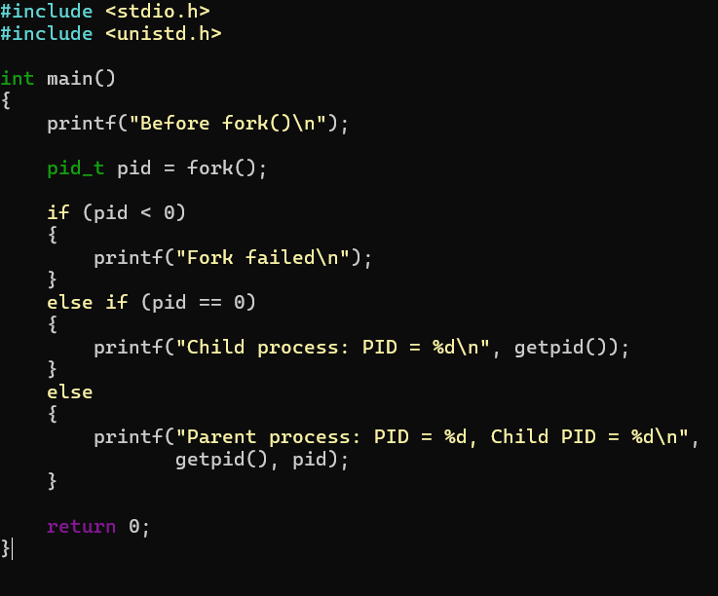

Output: 